Kill Your Darlings: Image Curation
Saloni Mahadik — General AI Fluency, Week 3

1. Image Content Map
What each portfolio piece needs, and where it stands right now:
Piece | Image needed | Status | Real or AI?
Correlix | Screenshot of upload UI + correlation table + chart | Captured — real screenshots already in hand | Real capture
Restaurant Websites | Screenshot of the live Balwas site (or Netlify page) | Captured — 4 real screenshots in hand | Real capture
Chess Game | Screenshot of the board mid-game | Pending — need to capture | Real capture (planned)
Forage Simulations | Certificates from Tata + Deloitte simulations | Captured — 7 certificates in hand | Real capture
Profile photo | A real photo of me, for the About section | Not decided yet — no photo chosen | Real photo when ready (never AI)
Hero texture (connective tissue) | Background pattern behind section headers | Generated + curated below | AI-generated
Correlix, Forage Simulations, and Restaurant Websites all have real captures in hand today. Only Chess Game still needs a screenshot — never an AI stand-in for the actual work.
Correlix — real captures in hand:
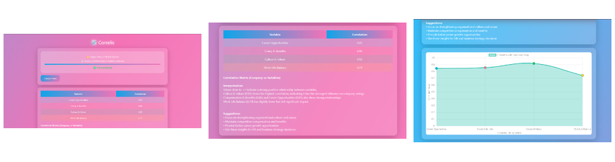
Three real screens: the file-upload interface, the resulting correlation table, and the chart it generates. These show the tool actually working end to end, not a mockup.
Forage Simulations — real certificates in hand:
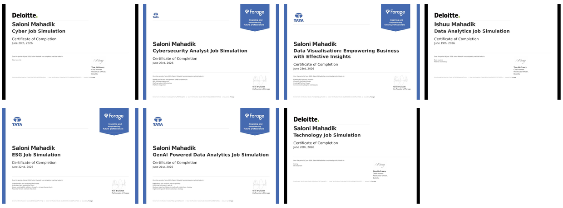
7 certificates across cybersecurity, data visualization, data analytics, ESG, and GenAI-powered analytics (Tata + Deloitte, via Forage). For the portfolio, curate down to the 2-3 most relevant to the target audience — a wall of 7 certificates reads as a list, not proof of judgment. Cyber (both) + GenAI Data Analytics make the strongest case for a data/dev-focused portfolio.
Restaurant Website (Balwas) — real captures in hand:
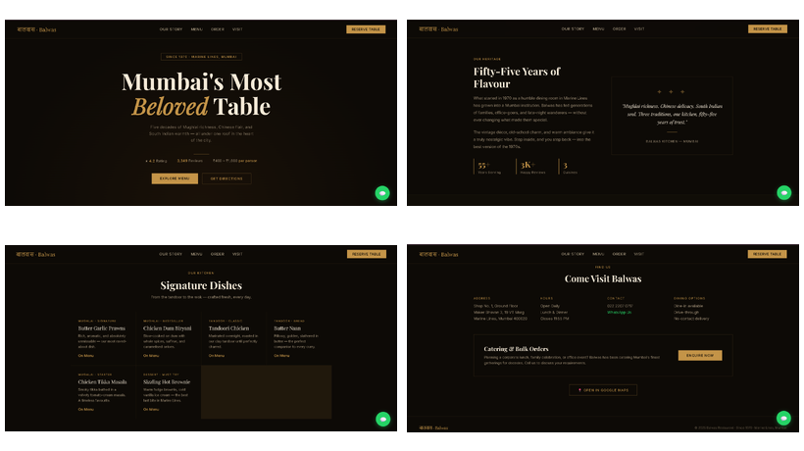
Four sections captured: hero, heritage story, signature dishes menu, and visit/contact. The dark charcoal-and-gold palette and serif display type are a deliberate brand choice for the restaurant — distinct from the portfolio's own identity kit, and that's correct: the case study should show the client's brand, not mine.

2. Connective Tissue — Generated Options
Three hero-texture options were generated in the same style/mood as the identity kit (Poppins, calm blue-on-white, one warm-orange accent). One was kept; two were rejected.
KEEPER — Option A: Dot Grid
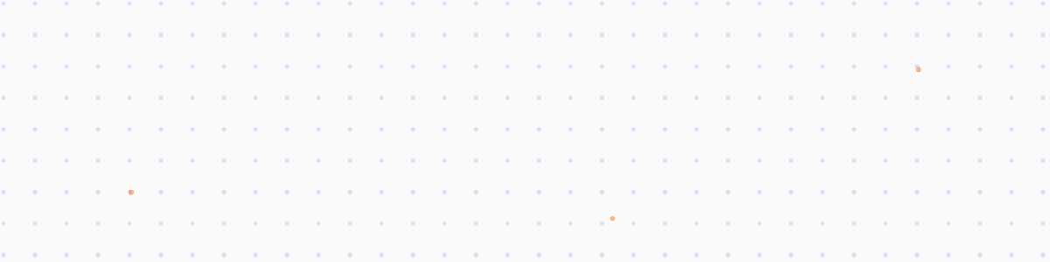
Calm enough to sit behind section headers without competing with the case studies — matches the identity kit's “clean enough to trust, simple enough that the work stays loudest” mood.
REJECTED — Option B: Organic Blobs

Rejected: too decorative and soft against the identity kit's sharp, geometric Poppins mood — the saturated curved shapes pull the eye instead of staying background texture, which defeats the point of connective tissue.
REJECTED — Option C: Diagonal Line Grid
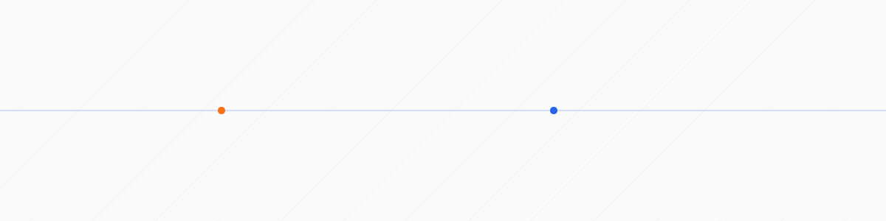
Rejected: the diagonal lines plus dots read as busy without adding meaning, and the overall feel skews cold/corporate rather than the “warm, honest, still learning” mood the kit is built around.

3. Real vs. AI — Where Each Call Was Made
• Correlix, Restaurant Websites, Chess Game, Forage Simulations → real screenshots only. These are proof of actual work; an AI-generated mockup would misrepresent what was built.
• Profile photo → real photo only, once one is chosen. No AI photo of myself — anything else would be dishonest about who's behind the work.
• Hero texture (background pattern) → AI-generated is appropriate here since it's decorative connective tissue, not proof of work — and it's kept in one consistent style across the whole site rather than a pile of different moods.

